SIMATS ENGINEERING
ASSESSMENT TOOL 2

COURSE CODE: CSA5116
COURSE NAME: Cryptography and Network Security

COURSE OUTCOME COVERED

CO2: Analyze Public Key crypto system strategies using RSA and key Exchange for
Encryption algorithm to strengthen information security. (BL4,BL5)

Scenario-Based : 20%
Total Marks: 50
Annexure A

Code of Conduct:

I Y.Naga Tharuni(192372338) certify that this submission is my original work and that I have adhered to the guidelines specified for this assessment.I understand that any violation of academic integrity rules will result in disciplinary action.

Signature of the student:Y.Naga Tharuni

Annexure A
- Secure Password Storage in Web Applications

Introduction
Web applications store passwords to authenticate users. If passwords are stored insecurely, attackers can compromise user accounts after a database breach.
A. Explain why storing plaintext passwords is insecure.
Plaintext passwords are dangerous because they are stored exactly as entered. Anyone who gains database access can immediately read every password. Attackers often reuse stolen passwords to access email, banking, and social media accounts because many users reuse the same password. Employees with database access may also misuse plaintext passwords.

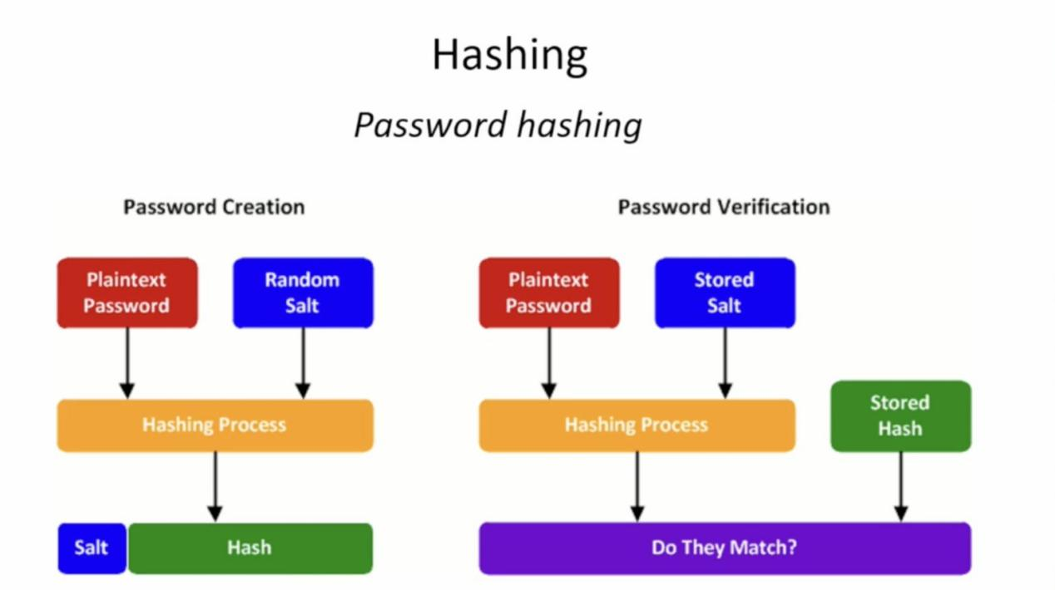

B. Suggest a secure method for storing passwords and justify your choice.
The recommended solution is salted password hashing using algorithms such as Argon2, bcrypt, or PBKDF2. A random salt is generated for every password, the password and salt are combined, and a slow hashing algorithm produces a hash value. Only the salt and hash are stored. During login, the entered password is hashed again and compared with the stored hash.
Advantages: protects against rainbow-table attacks, slows brute-force attacks, and prevents recovery of original passwords.
Real-world example: Most modern websites use bcrypt or Argon2 instead of storing passwords directly.
Conclusion: Password hashing with unique salts is the safest method for protecting user passwords.
2. Digital Signature for Document Authentication
Introduction
Digital signatures prove who signed a document and whether it has been modified.
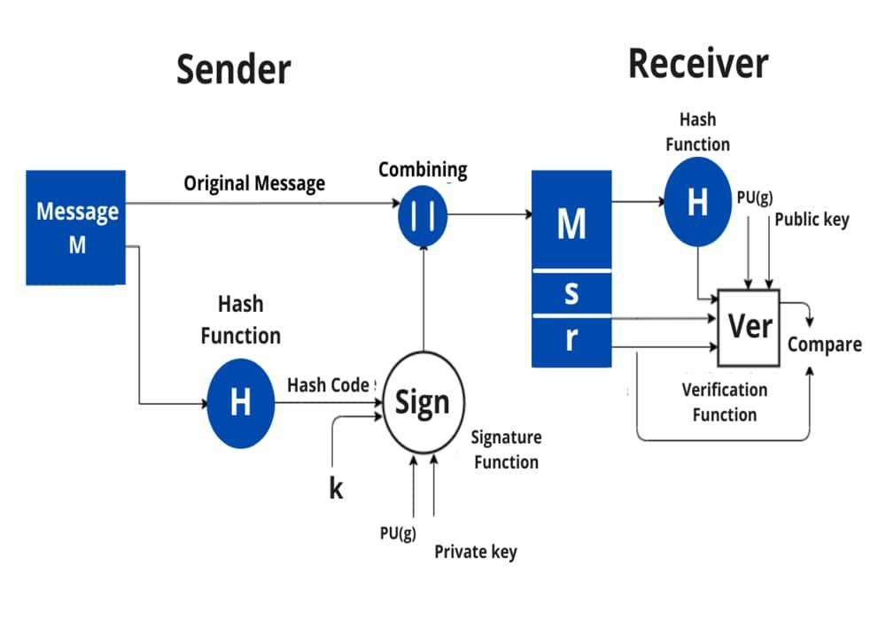
A. Explain how digital signatures can be used in this scenario.
The sender first computes a hash of the document using SHA-256. The hash is encrypted with the sender's private key to create the digital signature. The receiver computes a new hash and decrypts the signature using the sender's public key. If both hashes match, the document is authentic.
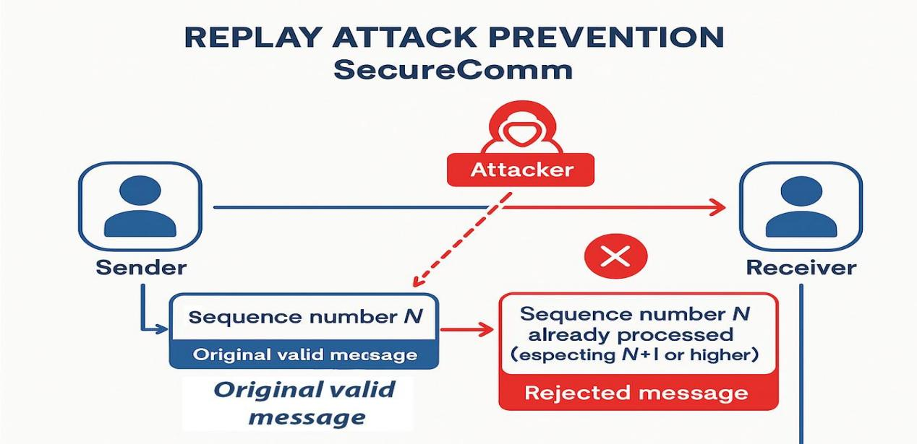
- Justify how this method ensures both integrity and non-repudiation.
Integrity is ensured because even one changed character creates a different hash. Non-repudiation is ensured because only the sender owns the private key used to generate the signature, so the sender cannot deny signing the document.
Applications: e-governance, PDF signing, contracts, banking.
Conclusion: Digital signatures provide authentication, integrity and non-repudiation.
3. Preventing Replay Attacks
Introduction
Replay attacks reuse captured messages to perform unauthorized transactions.
- Explain how replay attacks occur.
An attacker captures a valid payment request and retransmits it later. If the server cannot detect duplicates, it processes the transaction again.
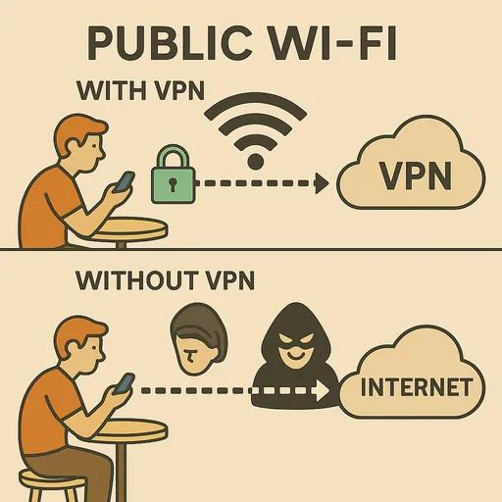
B. Suggest a cryptographic technique to prevent such attacks and justify your answer.
Use nonces, timestamps and challenge-response authentication. Every request includes a unique nonce or timestamp. The server accepts it only once or only within a short time window. Replayed messages are rejected.
Benefits: prevents duplicate transactions, improves trust and protects financial systems.
Conclusion: Freshness values such as nonces and timestamps effectively prevent replay attacks.
4. Secure Communication over Public Wi-Fi
Introduction
Public Wi-Fi is usually untrusted and may expose sensitive information.
A. Identify the risks involved in this scenario.
Risks include packet sniffing, man-in-the-middle attacks, fake hotspots, session hijacking and credential theft.
B. Recommend a secure communication method and justify how it protects user data.
Use HTTPS (TLS) or a VPN. TLS encrypts communication between browser and server, while VPN encrypts all traffic through a secure tunnel. Attackers cannot easily read or modify encrypted data.
Examples: online banking, email, cloud storage and e-commerce websites.
Conclusion: Encrypted communication protects confidentiality, integrity and authentication.
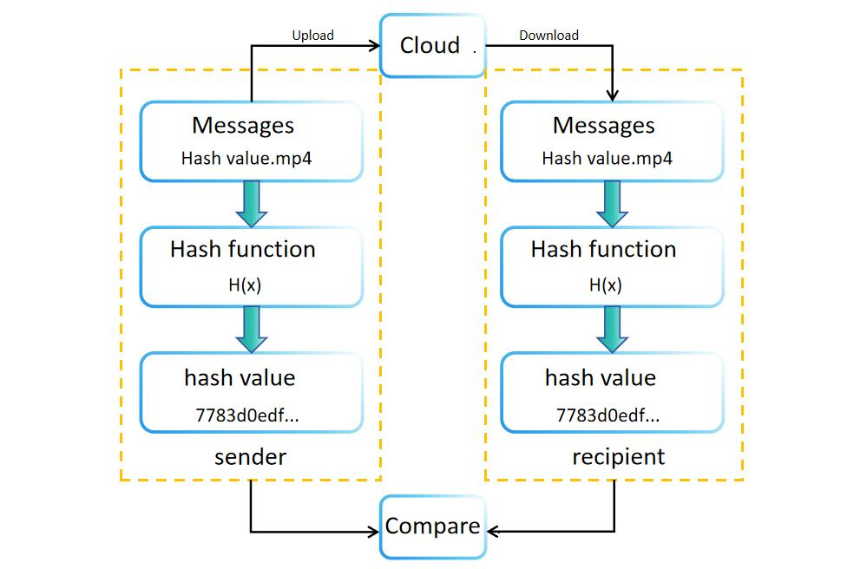
5. Data Integrity in Cloud Storage
Introduction
Organizations must ensure cloud data has not been modified.
- Explain how hashing can be used to verify data integrity.
Hashing algorithms such as SHA-256 generate a fixed-length digest. The file hash is computed before upload and checked again after download. Matching hashes confirm integrity.
- Suggest an additional mechanism to enhance trust and justify your answer.
Add digital signatures or Message Authentication Codes (MACs). Digital signatures verify both integrity and authenticity, while MACs verify integrity between trusted parties.
Benefits: detects tampering, increases trust, supports compliance and auditing.
Conclusion: Combining hashing with digital signatures provides strong protection for cloud data.

